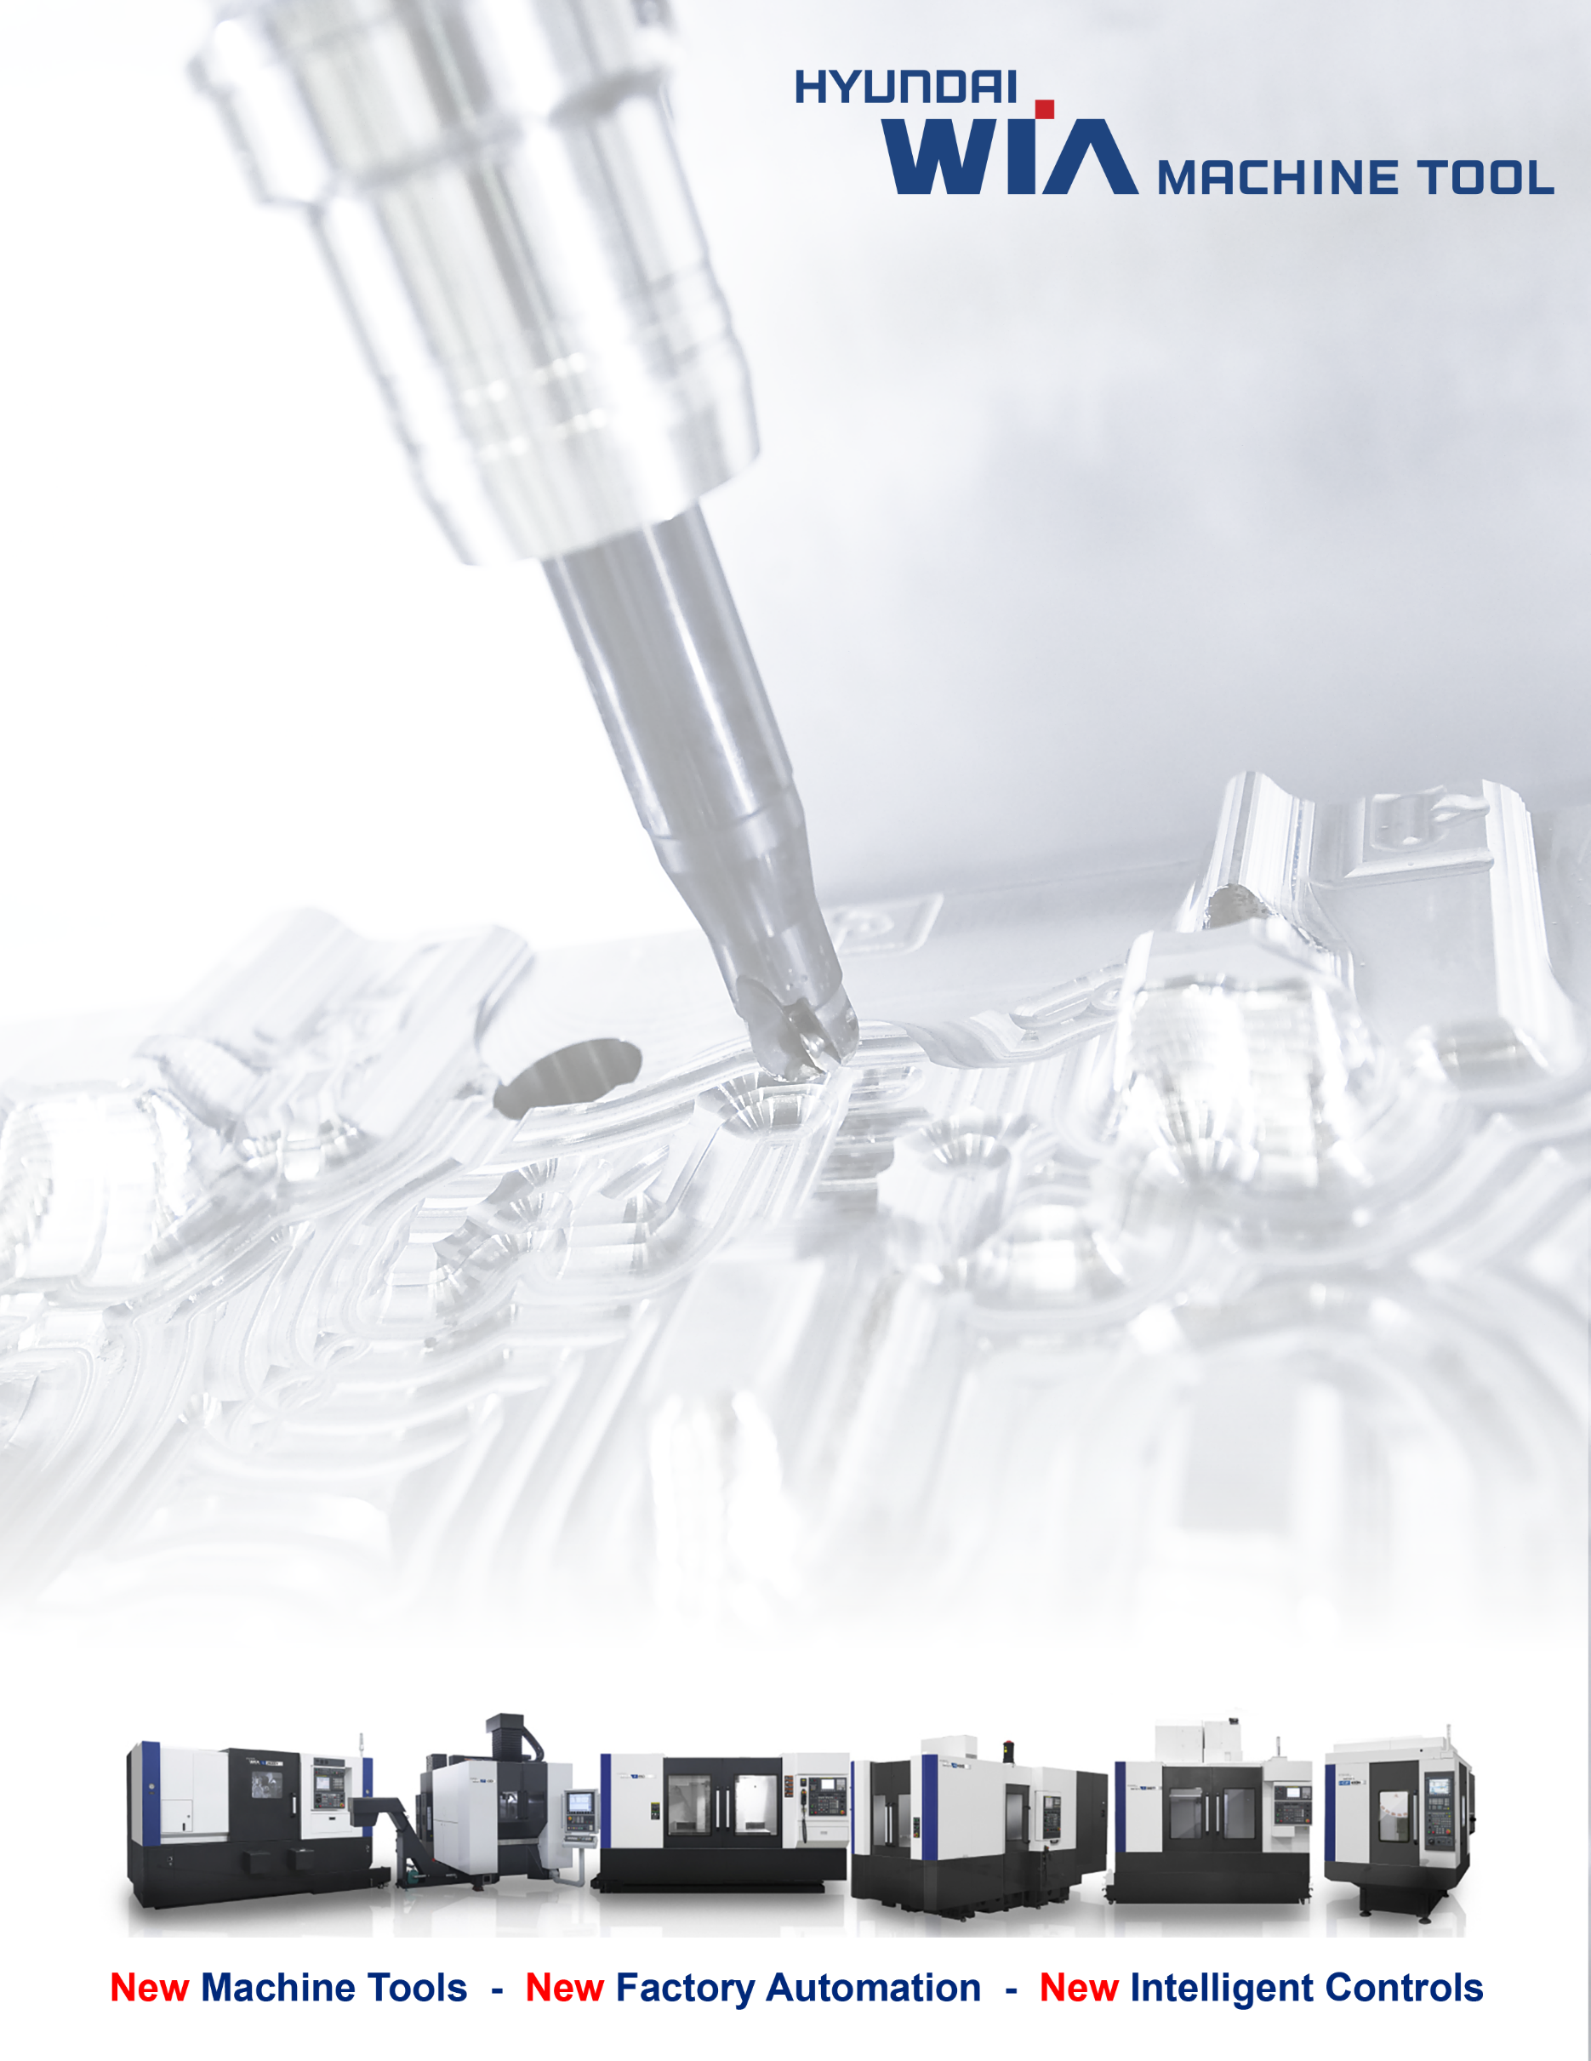
KF6700B II
High Precision Vertical Machining Center

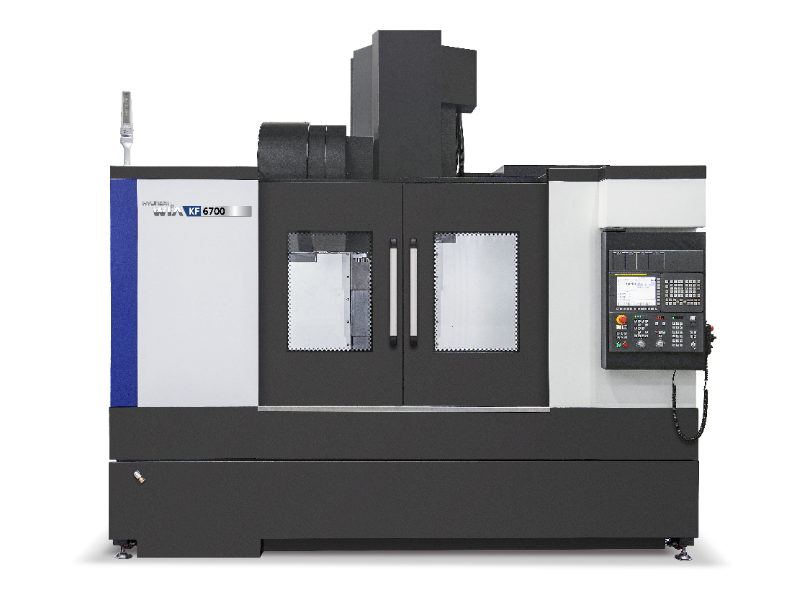

Proposal for: Customer Name

KF6700B II

High Precision Vertical Machining Center

The KF6700B II is designed by Hyundai WIA with years of experience and the latest technology, maximizes productivity and provides stiffness and rigidity. KF6700B II offers Hyundai value at an economical and affordable price, and provides high productivity and profitability and matches typical of complex, contoured geometry associated with medical production.

■ FEATURES

- Hyundai Wia Fanuc i Series - Smart Plus Control
- Powerful 20.1 HP (15 kW) spindle motor [24.8 HP (18.5 kW)]
- Max. 8,000 RPM Direct Driven Spindle [12,000 RPM Direct Spindle_Opt.]
- 59" x 26.4" (1,500 x 670mm) Table Size
- 2,866 lbs (1,300 kg) Load Capacity
- Spindle Oil chiller system option (12k:Std.)
- BCV # 40 taper [HSK tool holder_opt.]
- Fast 30m/min (1,181 IPM) X, Y and 24m/min (945 IPM) Z axis rapid traverse
- All Axis Large Box guideway
- ATC 30 Tools [40T_Opt.]
- “Y” shape ribbed column structure
- Metal plate coupling on all axes
- 290 PSI through the spindle coolant
- Remote Manual Pulse Generator
- Spindle override 0% to 150% (10% Unit)
- Massive Meehanite cast iron bed
- Double Pre-Tensioned Ball screws
- Rigid tapping
- Program and data protection key switch
- Slanted telescopic way covers
- Chip Conveyor (38.5" discharge height, Side_Left)
- Flood coolant with large separate coolant tank
- 3 color tower signal light
- Full enclosure splash guard

※If you need to change the direction of the chip conveyor, please contact us.

■ SPECIFIACTIONS

TRAVEL:
X axis travel 1,300mm (51.2")
Y axis travel 670mm (26.4")
Z axis travel 635mm (25")
Table top to spindle nose 150 ~ 785mm (5.9" ~ 30.9")
Column to spindle center 730mm (28.7")

TABLE:
Table size 1,500 x 670mm (59" x 26.4")
Allowable load 1,300kg (2,866 lbs)
Table T slot spacing x width (5) x 125 x 18mm (4.92" x .71")

SPINDLE:
Spindle Speed 8,000 rpm [12,000 rpm_Opt.]
Spindle Taper BCV #40
Pull Stud (Retention Knob) 45°
A.C. spindle motor (30min) 15 kW (20.1 HP) [18.5 kW (24.8 HP)]
Spindle torque (30 min) 286 N.m (210.9 lbf.ft) [118 N.m (87 lbf.ft)]

AUTOMATIC TOOL CHANGER:
Number of Tools 30
Tool Shank BCV # 40
Max. Tool Dia. Ø80mm (Ø3.1")
with empty adjacent pockets Ø125mm (Ø4.9")
Max. Tool Length 300mm (11.8")
Max. Tool Weight 8kg (17.6 lbs)
Tool change time (tool to tool) ??? sec
Tool change time (chip to chip) 3.7 sec

MOTION:
X, Y axis rapid traverse rate 30 / 30m/min (1,181 / 1,181 IPM)
Z axis rapid traverse rate 24m/min (945 IPM)
Max. Cutting Feed 15,000mm/min (590 IPM)
Least command increment .001mm (.0001")

GENERAL:
Machine Height 3,226 mm (127.0")
Floor Space (L) with side chip conveyor & tank 4,480 mm (176.4")
※Floor Space (L) without chip conveyor & tank 3,338 mm (131.4")
Floor Space (W) 2,662 mm (104.8")
Machine weight 9,000 kg (22,046 lbs)
Power required 29.1 kVA / 77 amp @ 220V [26.1 kVA / 69 amp]
Voltage required 205 - 235 Volts / 3 Phase

Specifications are subject to change for improvement without notice.

■ CONSTRUCTIONS

Column
“Y” shape ribbed column structure gives superior vibration absorption which happens during cutting process and during cutting process and also provide improved rigidity. To adopt three rows of column bearings provide excellent position accuracy, and it’s lubricated by oil suppling system.

Table
59" x 26.4" table size can handle most demanding cutting conditions, and it is fully supported by heavily ribbed saddle structure.

Spindle
The directly coupled spindle at a maximum revolution of 8,000 rpm, allows high –speed processing. It is driven by 20.1 HP (15kW) [24.8 HP (18.5 kW)] A.C. motor and comes with BCV # 40 taper. It is supported by precision class bearings that are lubricated by oil-air supply system. A refrigerated spindle cooling system maintains a constant temperature for high accuracy, regardless of the ambient temperature or cutting conditions. Cooling oil is circulated through jackets in the spindle head.

Spindle Cooling System
The spindle cooling system minimizes thermal displacement which can happen during lengthy machining operations, and offers continued accuracy based on the thermal stability.

30 Tool Magazine [40 Tools]
Servo driven twin arm ATC provides excellent positioning accuracy, and the tool change speed has been improved. Using random access this tool changer delivers instant waiting tool availability even during short cutting cycle times. The cam actuated exchange arm provides a fast, reliable 1.5 second tool-to-tool and 3.7 second chip to chip cycle time.

Guideways
The KF-B II Series are equipped with box guideways to enable distributing its feeding force evenly to each slideway. It boasts excellent rigidity, a stable feed structure, and an increased box guide slideway, thus providing an excellent heavy-duty cutting performance. Each axis is directly connected to a highly reliable digital servo motor to provide high rigidity and minimal thermal displacement.

Double Anchored Ball Screw
The double anchored ball screw minimizes the expansion and contraction. And this provides outstanding positioning repeatability with minimized thermal growth. To adopt metal plate coupling between ball screw and servo motor reduces coupling breakage and back lash as well.

290 PSI Thru-Spindle Coolant System
High pressure coolant system (290 PSI) aggressively brings new technology to the metal cutting industry, and increases production by a proven 30%. It provides longer tool life, longer coolant life and superior chip control. A cyclone filtering system with 50-micron element protects the spindle and the vital rotary union from contamination. The large 390 liters (103 gallon) tank stores an ample supply of coolant and is isolated from the machine bed to prevent heat transfer.

1,000 PSI High Pressure Coolant (option)

■ CONTROLLER
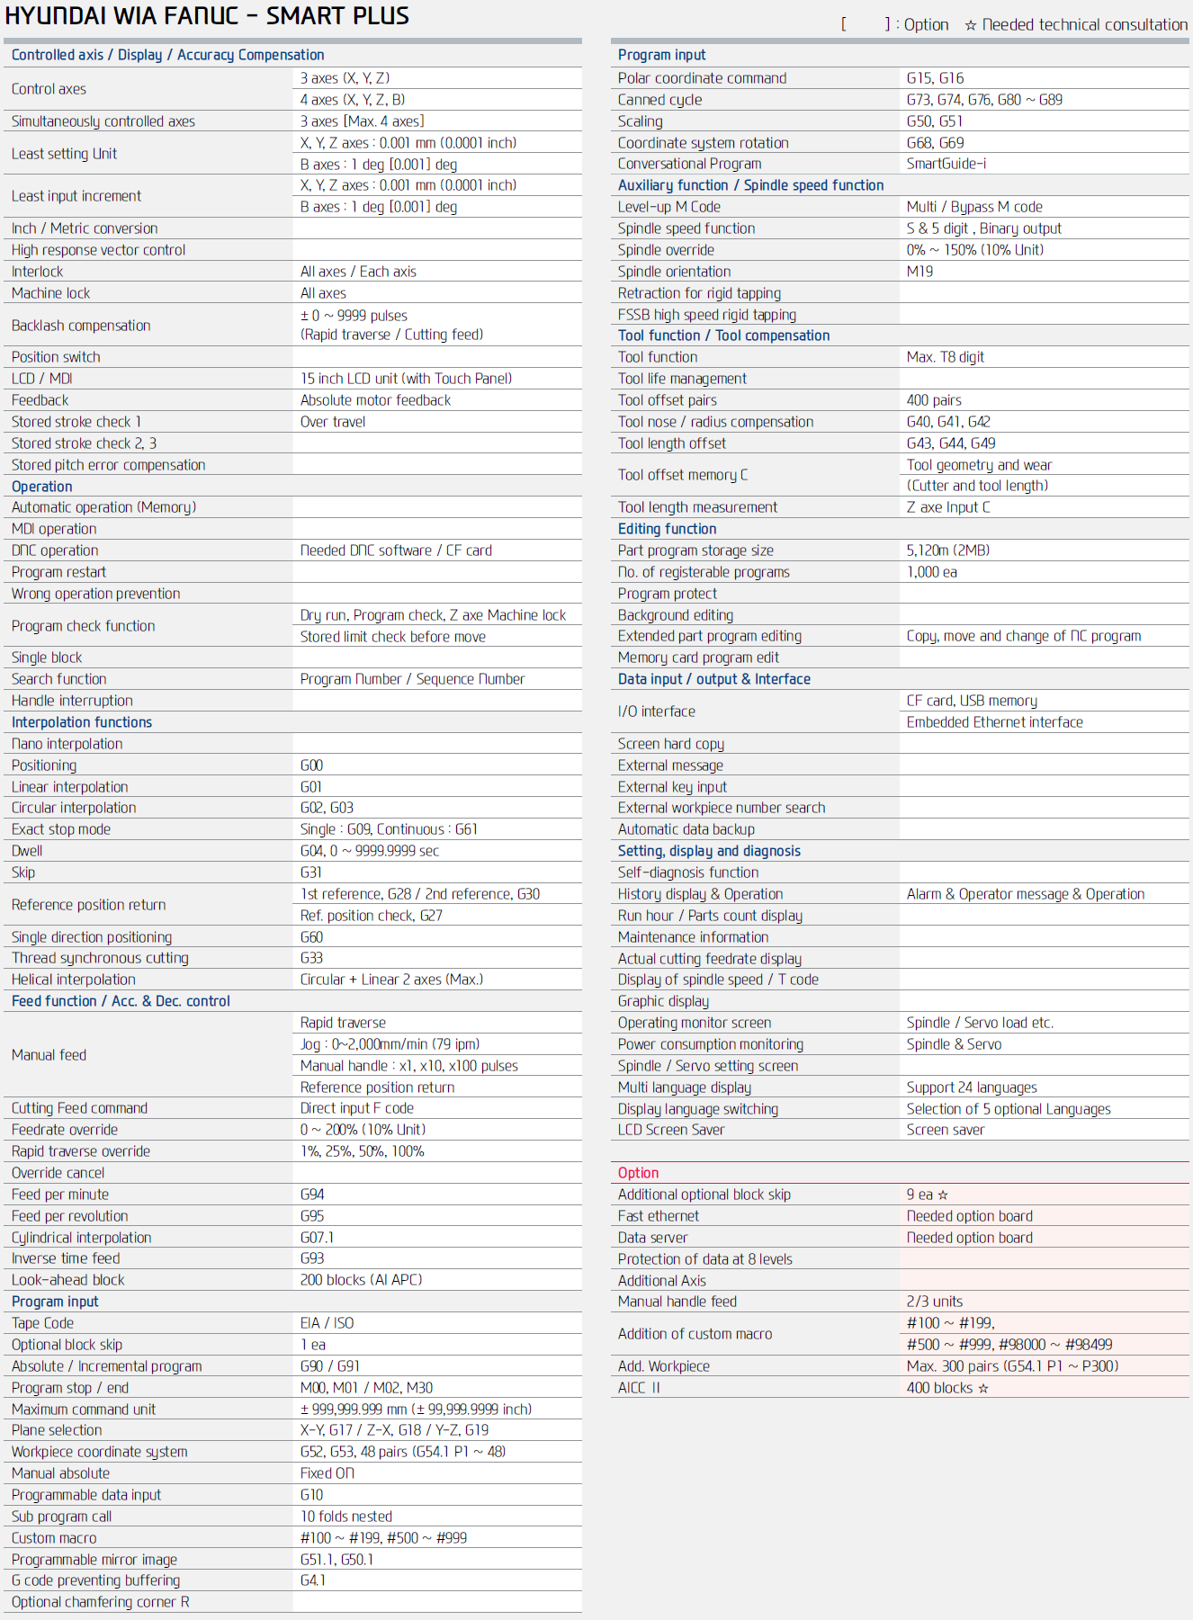

■ STANDARD FEATURES

- Hyundai Wia Fanuc i Series - Smart Plus Control
- Max 8,000 rpm direct driven spindle
- Powerful 20.1 HP (15 kW) spindle motor
- High precision spindle with double-row angular contact ball bearings
- BCV # 40 Spindle Taper
- Spindle orientation
- Spindle override
- 290 PSI through the spindle coolant.
- Massive Meehanite cast iron bed
- All Axis Large Boxguide way
- Double Pre-Tensioned Ball screws
- Fast 30m/min (1,181 IPM) X, Y and 24m/mi m(945 IPM) Z axis ripid traverse
- Rigid tapping
- Custom Macro (User Definable)
- Cam Type Double Arm ATC 30 Tools
- Portable Manual Pulse Generator
- Program and data protection key switch
- Telescopic way covers
- Internal spiral chip conveyor
- Chip Conveyor (38.5" discharge height)
- Flood coolant with large separate coolant tank
- Work light
- 3 color tower signal light
- Instruction manual, parts list, and electrical drawings
- Fanuc operator and maintenance manuals
- One-year machine warranty: Parts and Labor
- Two-year control and motor warranty: Parts and Labor

PRICE FOR MACHINE AS DESCRIBED ABOVE
KF6700B II with HYUNDAI WIA FANUC i Series - Smart Plus Control $ 000,000.00

■ OPTIONS
● : Standard, Ο : Option, ☆ : Prior Consultation - Non Application, ★ : Offer Required
 |  |  | KF6700B II
8,000 RPM | DIRECT SPINDLE |  | ●
12,000 RPM | DIRECT SPINDLE |  | ○
AIR BLOW | CUTTING AIR BLOW |  | $1,250
AIR GUN |  |  | $1,080
AIR CONDITIONER |  |  | $2,580
TABLE | T-SLOT |  | ●
ATC | 30EA |  | ●
 | 40EA |  | $6,000
AUTO DOOR |  |  | $3,430
AUTO POWER  CUT OFF DEVICE | NFB (SHUNT TYPE) |  | $720
 | ELB TYPE |  | $2,580
AIR BLOW FOR TLM & TBD |  |  | $830
AUTO TOOL  MEASURING DEVICE | LASER | RENISHAW(NC4) | $9,290
 |  | RENISHAW(TRS-2) | $3,720
 |  | MARPOSS(ML75) | $13,560
 | TOUCH | RENISHAW(TS27R) | $2,790
 |  | MARPOSS(T18-E32) | $3,630
AUTO WORK  MEASURING DEVICE(OPTICAL) | RENISHAW | OMP60 | $8,730
 |  | RMP60 | ★
 |  | RMP600 | ★
 | MARPOSS | E83C-TXL110 | $13,000
 |  | T25-E86N | $13,930
CHIP CONVEYOR  (EXCLUDING SHIPPING COST) | SIDE | HINGED (LEFT) | ●
 |  | SCRAPER | $5,360
 | REAR | HINGED | $7,500
 |  | SCRAPER | $7,500
CHIP BOX | FIXED TYPE |  | $610
 | SWING TYPE |  | $1,330
 | FIXED LARGE TYPE |  | $1,460
COOLANT | GUN |  | $1,220
 | JET/NIAGARA |  | $1,720
 | OIL SKIMMER |  | $2,360
HIGH COLUMN OPTION | 300MM (ONE PIECE COLUMN) |  | $3,220
Controller | NC F-0i |  | ●
 | NC F-32i |  | X
 | NC F-31i |  | X
PATROL LAMP  (LED TYPE) | R. G, Y (3 COLORS) |  | ●
 | R. G, Y (3 COLORS) + BUZZER |  | $470
SPINDLE THRU COOLANT | 20kgf | W/O COOL JET | ●
 | 30kgf(20L) |  | $6,690
 | 70kgf(22.8L) | CYCLONE | $9,850
SCALE, LENEAR | HEIDENHAIN | X-AXIS | $5,390
 |  | Y-AXIS | $4,090
 |  | Z-AXIS | $4,280
SPINDLE MOTOR  POWER UP (MAIN) | 11/15KW |  | ●
 | 7.5/18.5KW_12,000rpm |  | ○
SPINDLE TAPER | STANDARD |  | BCV # 40
 | HSK-A63 |  | $4,650
SPINDLE SPEED | 8,000RPM |  | ●
 | 12,000RPM |  | ○
 | 15,000RPM |  | X
 | 20,000RPM |  | X
SPINDLE  OIL COOLING DEVICE | OIL CON. | STD RPM | $3,000
 |  | OPT RPM | ●
TOP COVER | FOR SP. THRU COOLANT |  | ●
TOOL MONITORING SYSTEM | 1 Channel, Marposs |  | $9,290
 | 2 Channel, Marposs |  | $12,080
 | 3 Channel, Marposs |  | ★
 | 4 Channel, Marposs |  | ★
 | BUILT-IN FANUC CRT (HWTM) |  | $2,980
TRANSFORMER | 35 KVA |  | $1,490
 | CABLE |  | $430
SPECIAL COLOR | Old Hyundai-WIA or Customer Special Color |  | $1,210

List Price for Machine and Options: $000,000.00
Discount machine and options - $00,000.00
Transportation of machine & options 00,000.00

Price for (1) KF6700B II : $0,000,000.00

HYUNDAI WIA Machine Tool America Co.
Limited Warranty

Hyundai Wia Machine Tool America (“HWMA”) warrants to the original purchaser, other than a purchaser for resale, (the “Purchaser”) that HWMA’s machine tools shall be free of defects in materials and workmanship. For a period of one (1) year from completion of installation, or for a period of fifteen (15) months from date of shipment, whichever is earlier, HWMA will, at its sole and exclusive discretion, either replace or repair any machine or part thereof defective in workmanship or material, at no charge to the Purchaser.

All warranty repairs must either be performed by or authorized by a HWMA’s Authorized Service Organization. To obtain warranty service, Purchaser must contact their local HWMA Authorized Service Organization. Purchaser must provide verification of the date of delivery/installation when requesting warranty service (dated installation report). Ground freight charges (UPS regular or common carrier truck) for all warranty replacement parts are paid by HWMA. If machine is not operational, the HWMA will pay next-day air shipment charges for necessary parts weighing 100 lbs. or less. Materials or parts alleged to be defective shall be returned to HWMA, at HWMA’s request, transportation charges prepaid. After the warranty repair or replacement of a defective part, HWMA’s warranty for such part shall continue for ninety (90) days or for the remainder of the original Limited Warranty, whichever is longer.

WARRANTY LIMITATIONS
This warranty shall remain in effect only if the machine is used and maintained in accordance with all operating and maintenance instructions set forth in the manuals and instruction sheets furnished by HWMA. HWMA shall have no liability to repair or replace defective parts until the Purchaser has fulfilled its payment obligations. No allowance will be made for repairs or alterations made without HWMA’s prior written consent or approval. The limited warranty provided by HWMA excludes the following:

- Damage, malfunction, or failure caused by or resulting from improper maintenance, misuse, neglect, accident or any other cause beyond the control of the HWMA.

- Damage, malfunction, or failure caused by modification of the machine (mechanical or electrical) without written authorization by HWMA.

- Damage, malfunction or failure caused by installation or use of accessories or peripherals not purchased through or authorized in writing by HWMA.

- Paint, batteries, filters, fluids, fuses, light bulbs, or any commonly expendable item.

- Damage to machines and/or components while being transported from HWMA’s warehouse or facility to destination.

- Accessories or peripherals not manufactured by HWMA, which shall be subject only to whatever warranty that is supplied by the manufacturer of such product.

- Fanuc CNC control, Fanuc spindle motors and Fanuc servo motors, spindle and servo drives, which are covered by a two (2) year manufacturer warranty.

No person, agent, distributor, dealer or company is authorized to change, modify or amend the terms of this Limited Warranty in any manner. HWMA makes no warranties, guarantees or representations, express or implied with respect to the machine tool, or parts thereof, except to the extent such warranty is set forth herein. The equipment covered does not necessarily comply with any codes or standards unless specifically quoted, ordered, and so accepted.

THIS WARRANTY IS IN LIEU OF ALL OTHER WARRANTIES, EXPRESS OR IMPLIED, INCLUDING WITHOUT LIMITATION WARRANTIES OF MERCHANTABILITY OR FITNESS FOR ANY USE OR PURPOSE. HWMA’s LIABILITY UNDER THIS WARRANTY IS EXPRESSLY LIMITED TO ITS PROMISE TO REPAIR OR REPLACE THE DEFECTIVE GOODS. HWMA SHALL HAVE NO FURTHER LIABILITY IN CONTRACT OR NEGLIGENCE OR UNDER ANY OTHER THEORY OF LAW OR EQUITY FOR ANY DAMAGES, DIRECT OR INDIRECT, INCIDENTAL, SPECIAL OR CONSEQUENTIAL, OR ANY DELAY RESULTING FROM THE DEFECT.

Machine Investment Information

Terms: 00% down upon order placement, 00% due upon shipment of the machine tool, final 00% due 00 days after receipt of the machine tool.

Delivery:

Freight: The customer is responsible for all freight charges incurred with the delivery of the machine tool, options, and accessories.

Rigging: The customer is responsible for all rigging charges incurred.

F.O.B.: Port of entry.

Voltage/Air: The customer is responsible to provide electrical power and air supply to the machine. Please check with Hyundai-Wia or distributor for the voltage/air requirement of each machine.

Electrical: If approval of electrical equipment is requested pursuant to a State or County statute, any costs associated with changes due to an inspection or the cost of a certification will be the customer’s responsibility.

Training: Distributor will provide basic Operator and Program training at your facility. There is no charge for this training on new installations.

Warranty: Full 00 year warranty on machine tool and controller. Full 00 year service warranty provided by Distributor.

Validity: Price is valid for 15 days.

Cancellation: Canceled orders after the date of order placement shall be subject to a cancellation charge of equal to thirty percent (00%) of the purchase price

